Writing 1 Ingman 1

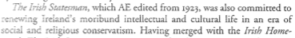

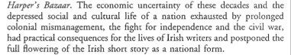

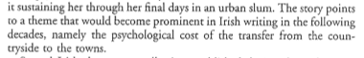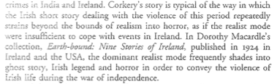

Writing 2- Longerman - National vs International themes

Overview of developmental form
Tease out key points he raises-

Impact of audience- writing for outside or familiar audience- impacts writing
Yeats left London because he didn’t want to become a ‘Professional Irishman’.

Irish writers write in colonial modes
Trapped between colonial and nationalist writing- writing in ireland, writing in Britain

America- promised chance for post-nationalist post-colonial writing
Freer market, new mixed audience with less of a pre-conditioned idea of Ireland and it’s writings

Escape from colonial/national inheritance

Dissident voice Frances Stuary criticized Frank O’Connor- described him as knitting short stories (derision)
O’Connor was seen as the master of the Irish short story
Stuart bitterly suggests that O’Connor hits a pattern which works and which people like
- writes stories to that pattern
- impact of the New Yorker on O’Connor
Sense of liberation- has its own complications

Influences
Writers see themselves in European terms- influence of Russian and French writers is immense
Chekhov, Turgenev, etc break new ground in 19th century
Looking to translations when trying to think of new ways to write
Technological influences too- Cinema
Cinematic qualities

Three types
Three things- regional/national/cosmopolitan
Cosmopolitan - seeing subject of your literature as transcending national boundaries
Transcends boundaries for socio-political ideas and trends that reflect international themes/other post-colonial trends

Why can’t be national and cosmopolitan though, both grounded and outward looking
That age old irish idea that what is irish is provincial and limiting- ashamed

Key characteristic of Irish writing was backward look- irish writing is always looking backwards- to what has gone before
This is absolutely fundamental for him
Ironically our past- we don’t know anything about our past because of history of colonization/social pressures
A defined feature of writing in Ireland

What does Irish writing look like today/ rather than 20/30 years ago
Paint Ireland today
Need nowadays to situate us as just another modern European culture
Reject that- culture and stereotypes

Why impulse?
Backward looking- must know your past to deal with trauma
Coming to terms with past- re-evaluating it

Read two Ingman pieces- read one short sotry and put together half a dozen points in relation to it.

Clash between appearance and reality- ingman’s trope

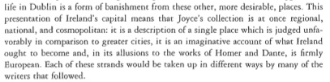

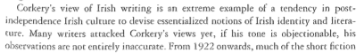

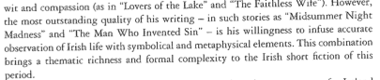

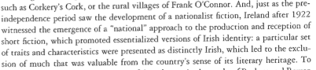

Writing 3

